ONLINE RENTAL HOUSE
ABSTRACT
This Web Application helps user to register individual home or apartment to assist you in finding the perfect rental home or property. Also, we can find your next rental from search view in your targeted area. This website is designed to attend to all our needs from buying property, selling property or renting/leasing of property in India. Here we found the better opportunity to invest our value of entire life. Property helps us to maintain the database of various property & agents’ information. It not only helps us to maintain the agent information but here we also allow agents to access the portal updated information across the global environment. We know it is a tiring to call individual property agents, arrange appointment, finding better time for appointment and they will assist you. For such complex process we provide a one simple online form which requires your basic information and we will assist in sort time period.

SYSTEM SPECIFICATION
HARDWARE SPECFICATION:
- Processor : P 4 700 GHz.
- RAM : 4 GB RAM
- Hard Disk Drive : 180 GB

SOFTWARE SPECIFICATION:

  - Operating System : Windows 7/8/10
  - Front End : JAVA
  - Back End : SQL
EXISTING SYSTEM
The housing sector remains vigilant to face the challenges of the change of the existing system. People migrating to other cities or states either for different purposes. Finding a shelter, which fits all the requirements of the customer is hard, most of them don’t match their needs.
DISADVANTAGES
- Very hard to find the way for houses
- We need to provide more commission to search house.
- Everyone is not comfortable to follow this.
PROPOSED SYSTEM
This system is take care for sales the house via application, the admin can be access to upload the house details, once the uploaded with photo user can getting attractive and more happy to visit the house, the purpose of this software is an user friendly.

ADVANTAGES
- Every user can visit the page after the registration
- Once the process has been done admin directly reach you, you don’t need to collect the details.
- All the process has been handling into the single application.

MODULES
- User Registration
When the user needs to search home or anything, should need to register. Once the user has been registered with username and password, they can able to login.
- Add Houses
The main role of admin for create the house and house details, also upload house images. Which details can be viewed in the user page, once the user liked can book it
- Houses Details
The registered houses are showing in the home page, after login user can view the page, admin also can be modified the house details as well. Once the house has been booked, we don’t show to the other users.
- Booking House
If user liked house, the user can book the house via this application, after the booking admin will get notify and reach them customer.
- House Images Upload & download
We have good option to provide the house images and uploading in to the server, if the user needs the pics just, we gave download option also there in the user page screen
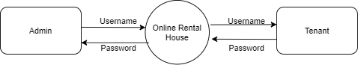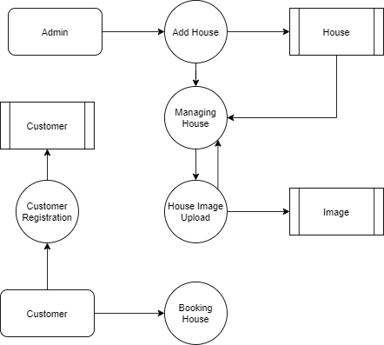

TABLE NAME: ADMIN

FIELD | DATA TYPE | SIZE | CONSTRAINT
Admin id | Int | 10 | Primary key
Username | Varchar | 30 | Not null
password | Varchar | 30 | Not null

TABLE NAME: HOUSE

FIELD | DATA TYPE | SIZE | CONSTRAINT
house id | Int | 10 | Primary key
House name | Varchar | 20 | Not null
Owner name | Varchar | 20 | Not null
Contact number | Int | 10 | Not null
Address 1 | Varchar | 30 | Not null
Address 2 | Varchar | 30 | Not null
Area name | Varchar | 30 | Not null
City name | Varchar | 20 | Not null
District name | Varchar | 30 | Not null
State name | Varchar | 10 | Not null
Land mark | Varchar | 20 | Not null
Pin code | Varchar | 6 | Not null
Total square fit | Varchar | 5 | Not null
Bed room | Int | 5 | Not null
Hall | Int | 5 | Not null
Kitchen | Int | 5 | Not null
Others | Varchar | 20 | Not null
Price details | Int | 5 | Not null

TABLE NAME: IMAGES

FIELD | DATA TYPE | SIZE | CONSTRAINT
Image id | Int | 10 | Primary key
House id | Int | 10 | Foreign key
Image path | Varchar | 30 | Not null
Image name | Varchar | 20 | Not null

TABLE NAME: CUSTOMER
FIELD | DATA TYPE | SIZE | CONSTRAINT
Customer id | Int | 10 | Primary key
Customer name | Varchar | 20 | Not null
Mobile | Int | 10 | Not null
Email | Varchar | 20 | Not null
Username | Varchar | 20 | Not null
Password | Varchar | 20 | Not null

TABLE NAME: BOOKING
FIELD | DATA TYPE | SIZE | CONSTRAINT
Booking id | Int | 10 | Primary key
Customer id | Int | 10 | Foreign key
House id | Int | 10 | Foreign key
Booking status | Varchar | 20 | Not null

